Contents

**1.0** **User Manual** 2

**1.1** **User** 2

**1.1.1** **View Donation** 2

**1.1.2** **Search Donation** 3

**1.1.3** **Make Donation** 5

**1.1.4** **View Donatary** 7

**1.1.5** **Search Donatary** 8

**1.1.6** **Contact Us** 9

**1.2** **Admin** 11

**1.2.1** **Login** 11

**1.2.2** **Donation Registration** 12

**1.2.3** **View Donation** 13

**1.2.4** **Update Donation** 13

**1.2.5** **Delete Donation** 15

**1.2.6** **Donatary Registration** 16

**1.2.7** **View Donatary** 17

**1.2.8** **Update Donatary** 18

**1.2.9** **Delete Donatary** 19

**1.2.10** **View Donor** 21

**1.2.11** **View Yellow Givers Fund** 21

**1.2.12** **Notification** 21

# **User Manual**

## **User**

### **View Donation**



For user to view donation, user require to enter Yellow Givers Donation website first where from the image above is Yellow Givers Donation homepage. Then user require to click on donation text on the menu bar.

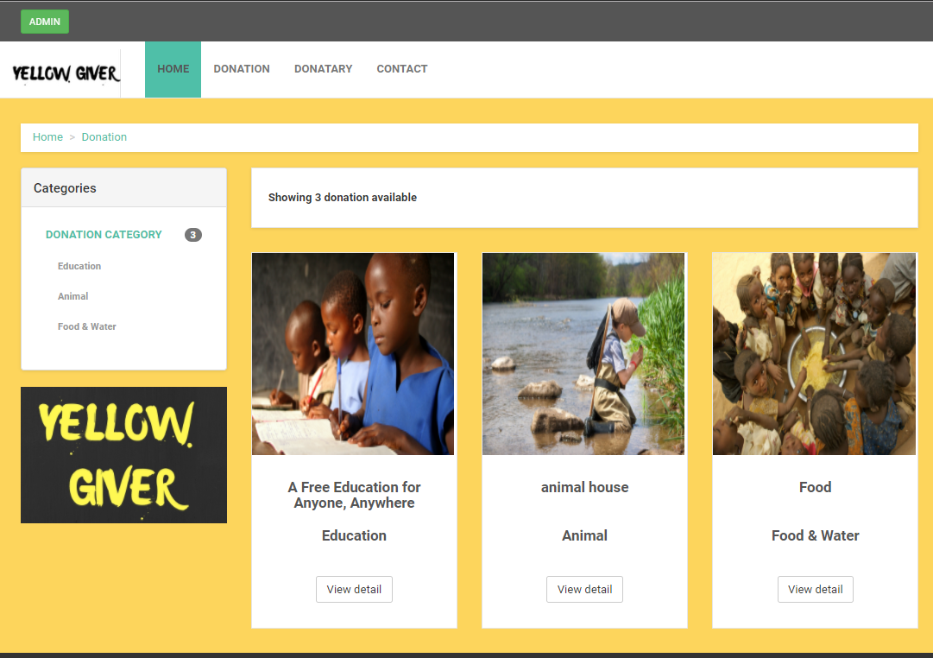

After user click on the donation text on the menu bar then user will be redirect to donation page as shown in above image where all of the donation exist will be display in this pages.

### **Search Donation**



For user to search donation, user require to enter Yellow Givers Donation website first where from the image above is Yellow Givers Donation homepage. Then user require to click on donation text on the menu bar.



After user click on the donation text on the menu bar then user will be redirect to donation page as shown in above image where all of the donation exist will be display in this pages. User are given features to search based on donation categories where at the right side of donation information, user can click on donation categories user wish to search.



After user click on selected donation categories then the page will display all of the donation information based on selected donation categories.

### **Make Donation**



For user to make donation, user require to enter Yellow Givers Donation website first where from the image above is Yellow Givers Donation homepage. Then user require to click on donation text on the menu bar.

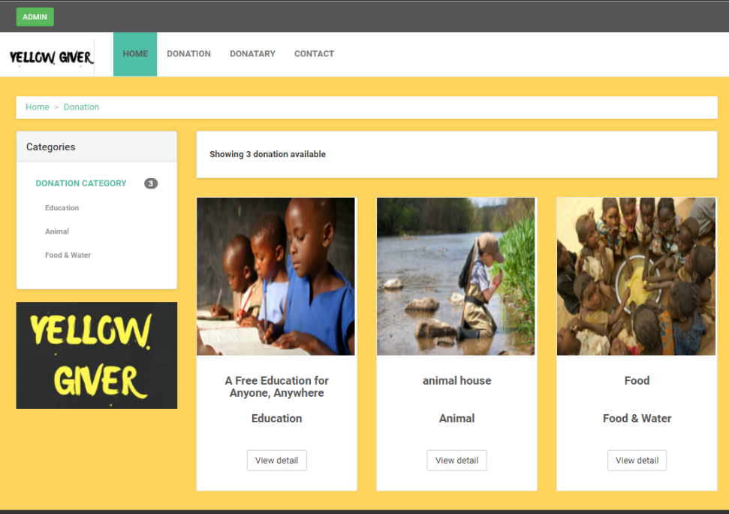

After user click on the donation text on the menu bar then user will be redirect to donation page as shown in above image where all of the donation exist will be display in this pages. User require to choose wish donation user want to make donation and to proceed to make donation user require to click on view detail button.

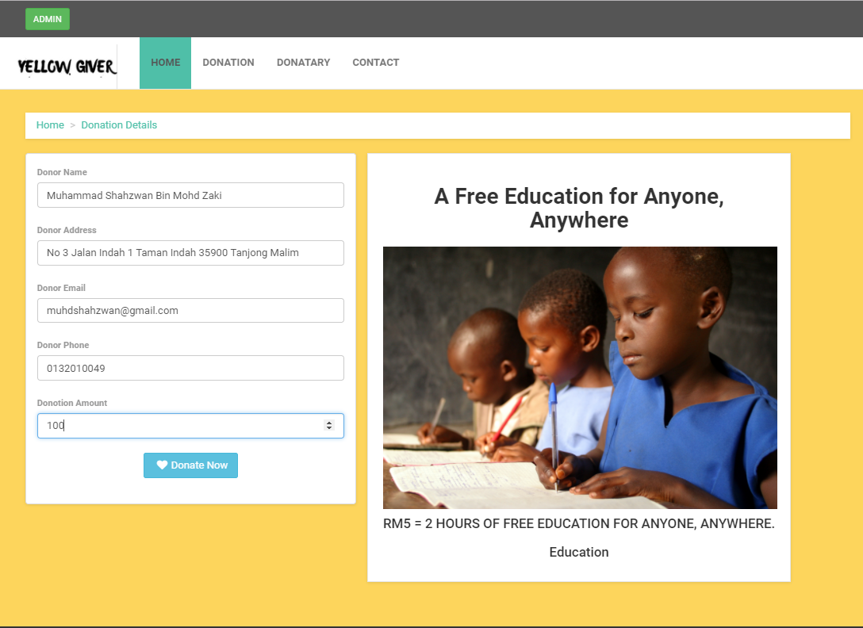

After user click on the view detail button then user will be redirect to donation details as shown in above image where user require to enter all of the details such as donor name, donor address, donor email, donor phone and donor amount. After all of the require details entered then user require click on donate now button.

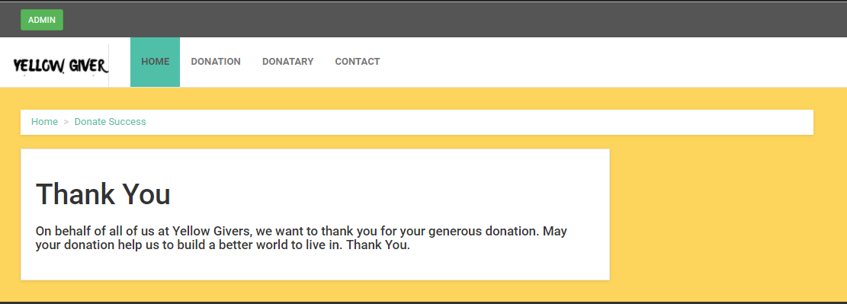

After user click on the donate now button then user will be redirect to donation success page as shown in above image where some information will be shown and user will receive an informative email based on enter email in donation details success.

### **View Donatary**



For user to view donatary, user require to enter Yellow Givers Donation website first where from the image above is Yellow Givers Donation homepage. Then user require to click on donatary text on the menu bar.

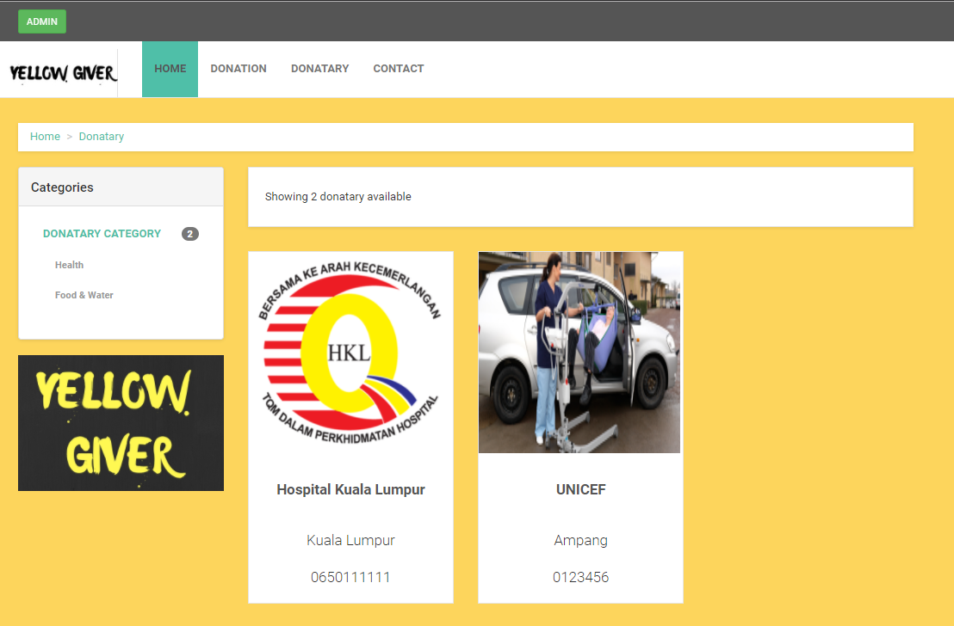

After user click on the donatary text on the menu bar then user will be redirect to donatary page as shown in above image where all of the donatary exist will be display in this pages.

### **Search Donatary**



For user to search donatary, user require to enter Yellow Givers Donation website first where from the image above is Yellow Givers Donation homepage. Then user require to click on donatary text on the menu bar.



After user click on the donatary text on the menu bar then user will be redirect to donatary page as shown in above image where all of the donatary exist will be display in this pages. User are given features to search based on donatary categories where at the right side of donatary information, user can click on donatary categories user wish to search.

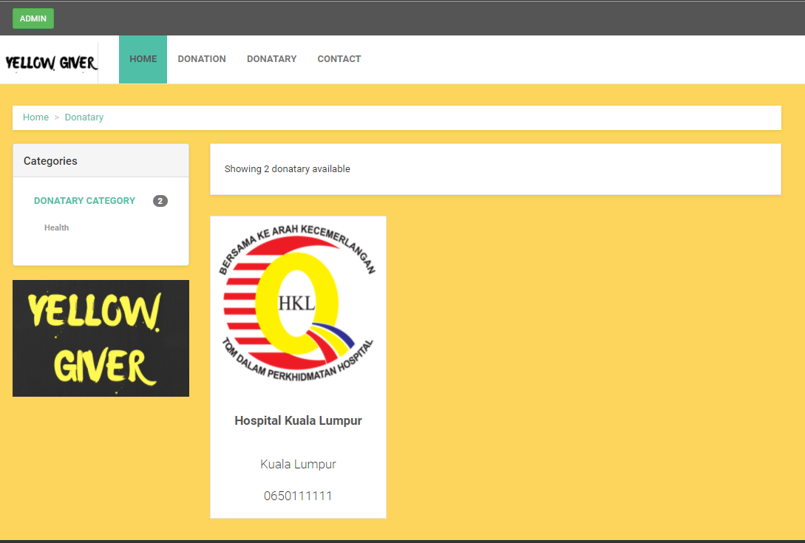

After user click on selected donatary categories then the page will display all of the donatary information based on selected donatary categories.

### **Contact Us**



For user to contact us, user require to enter Yellow Givers Donation website first where from the image above is Yellow Givers Donation homepage. Then user require to click on contact us text on the menu bar.

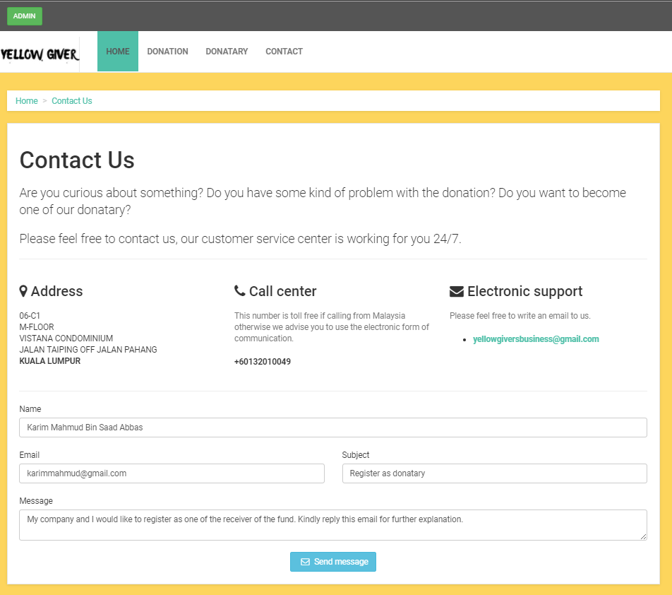

After user click on the contact us button then user will be redirect to contact us page as shown in above image where user require to enter all of the details such as name, email, subject and message. After all of the require details entered then user require click on send message button.

## **Admin**

### **Login**



For admin to login, admin require to enter Yellow Givers Donation website first where from the image above is Yellow Givers Donation homepage. Then admin require to click on admin button at the left top side.

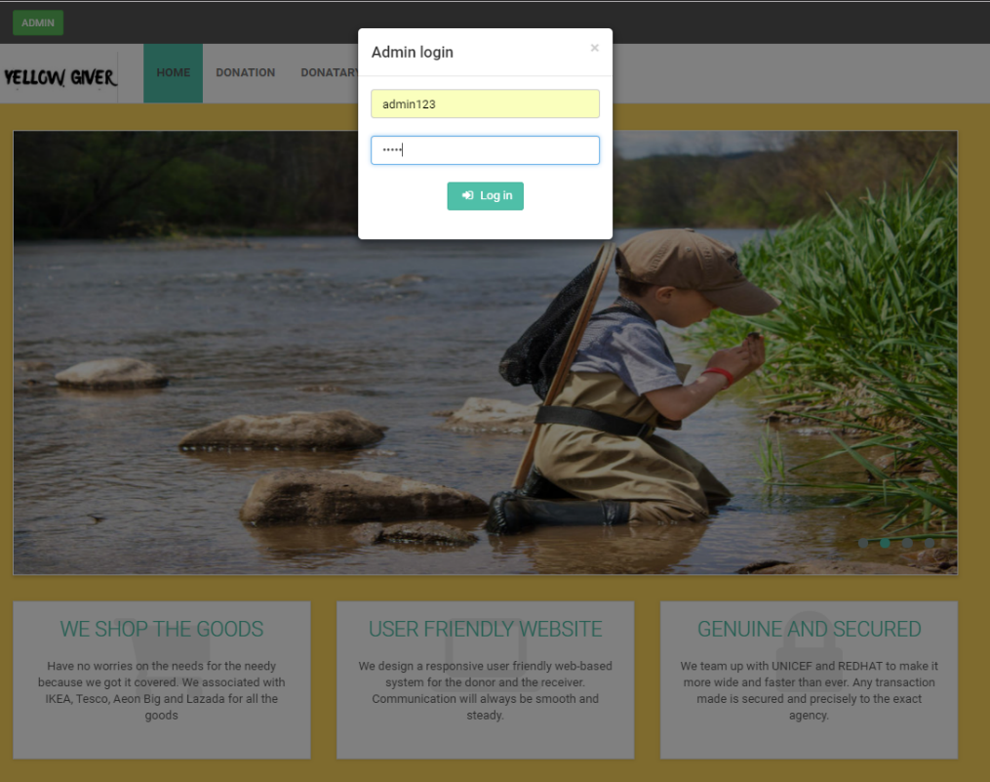

After admin click on the admin button then admin login will be display as shown in above image where admin require to enter all of the details such as username and password. After all of the require details entered then admin require to click on log in button.

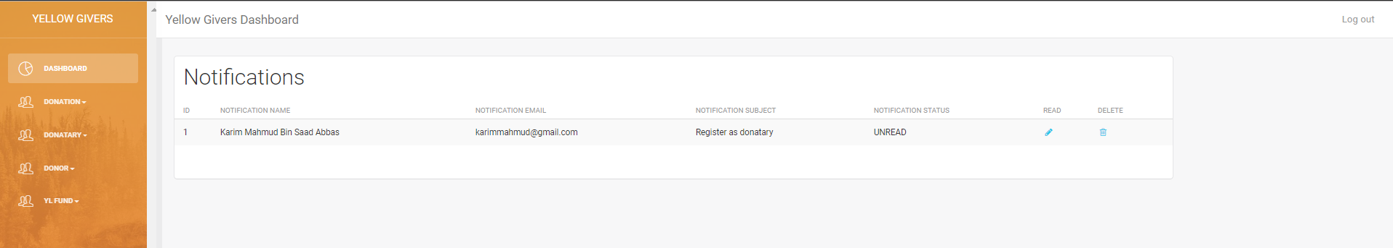

After admin click on the log in button then admin will be redirect to admin dashboard as shown in above.

### **Donation Registration**

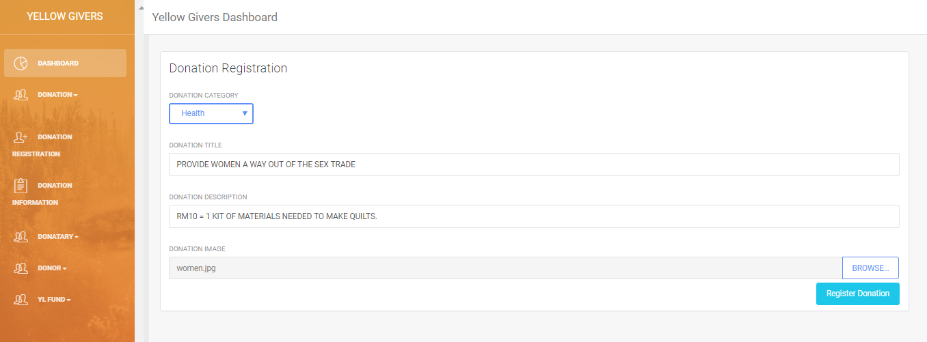

For admin to register donation, admin require to click on donation registration button at the left side then admin will be redirect to donation registration page. In donation registration page admin require to enter donation category, donation title, donation description, and donation image. After all of the require information are enter then admin require to enter register donation button.

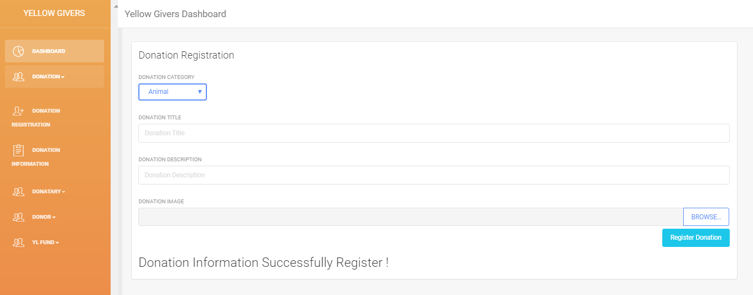

After register donation button is click on, then the message of donation information successfully register will appear showing that the donation details is register into database as show in above image.

### **View Donation**

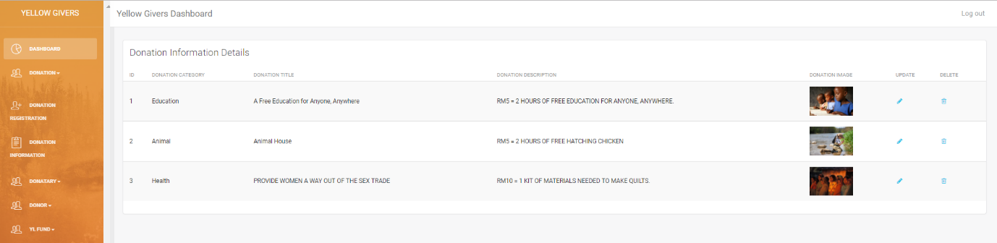

For admin to view donation, admin require to click on donation information button at the left side then admin will be redirect to donation information page. In donation information page all of the donation information are display in this page as show in image above.

### **Update Donation**



For admin to update donation, admin require to click on pencil icon button at the right side then admin will be redirect to donation update page.

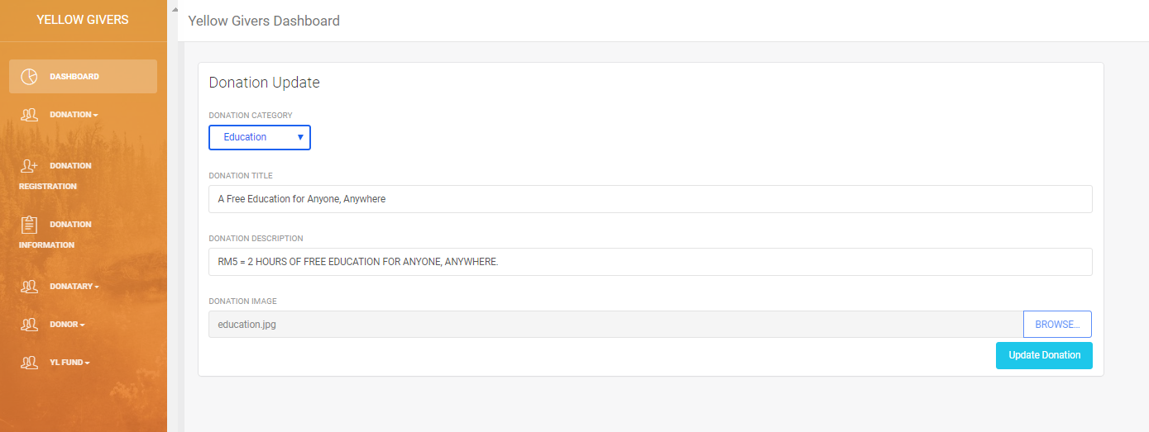

Image above is donation update page where after admin click on pencil icon button then admin will be redirect to this page. In donation update page admin able to update donation category, donation title, donation description, and donation image. After all of the required information are enter then admin require to click on update donation button.

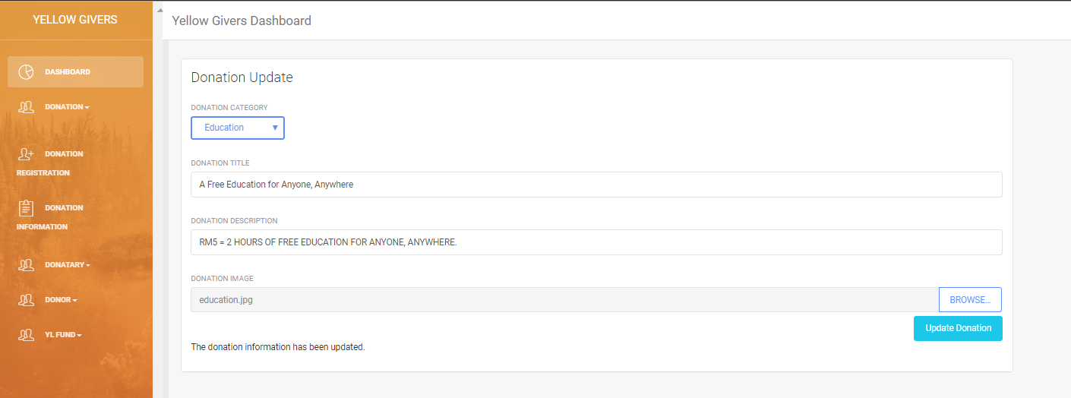

After update donation button is click on, then the message of donation information has been update will appear showing that the donation details have been update into database as show in above image.

### **Delete Donation**



For admin to delete donation, admin require to click on trash can icon button at the right side then admin will be redirect to donation delete page.

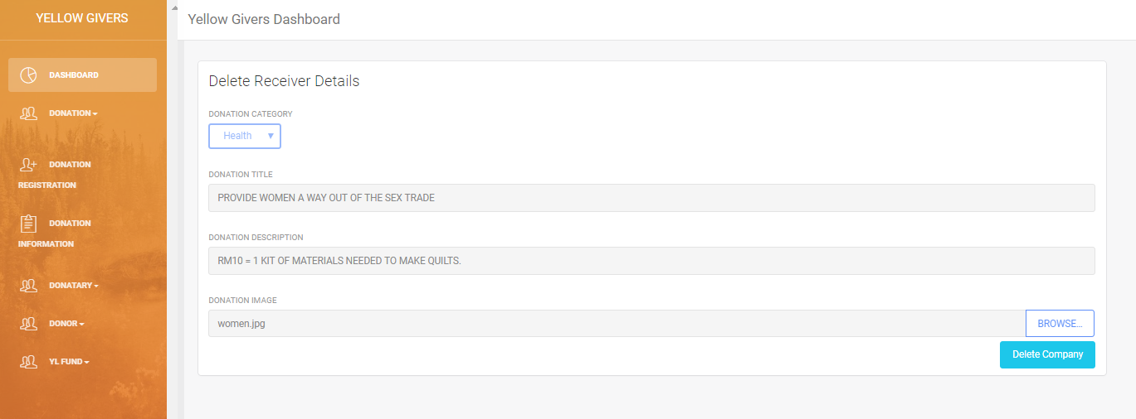

Image above is donation delete page where after admin click on trash can icon button then admin will be redirect to this page. In donation delete page admin can view the information of selected donation that wish to be deleted and if admin wish to proceed the admin require to click on delete donation button.

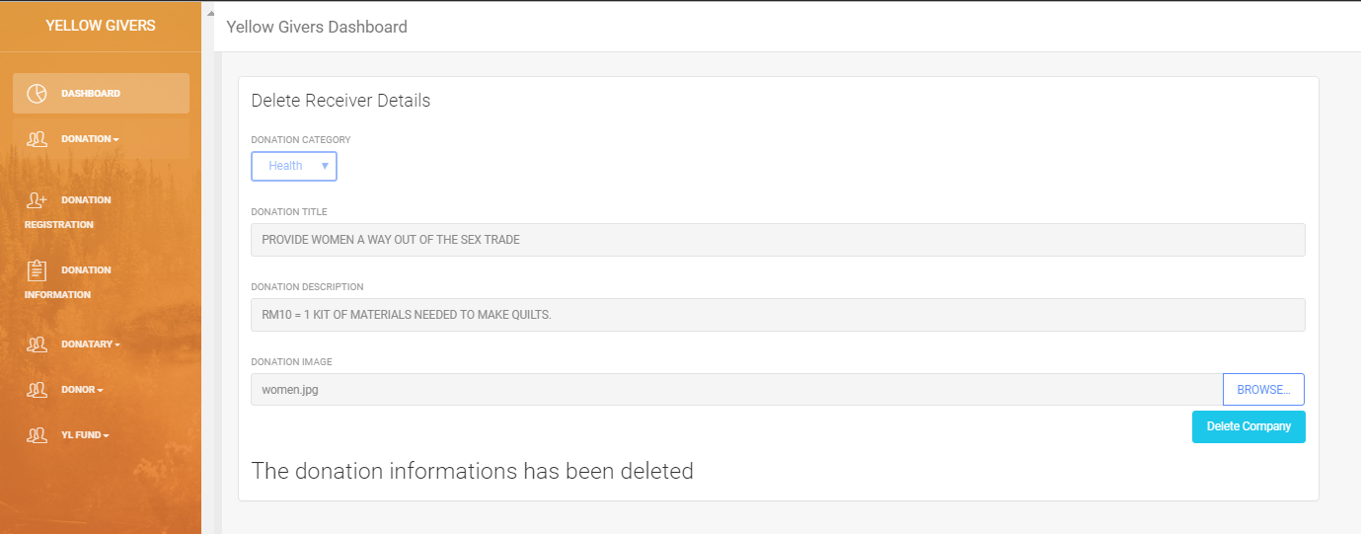

After delete donation button is click on, then the message of donation information has been delete will appear showing that the donation details have been delete from database as show in above image.

### **Donatary Registration**

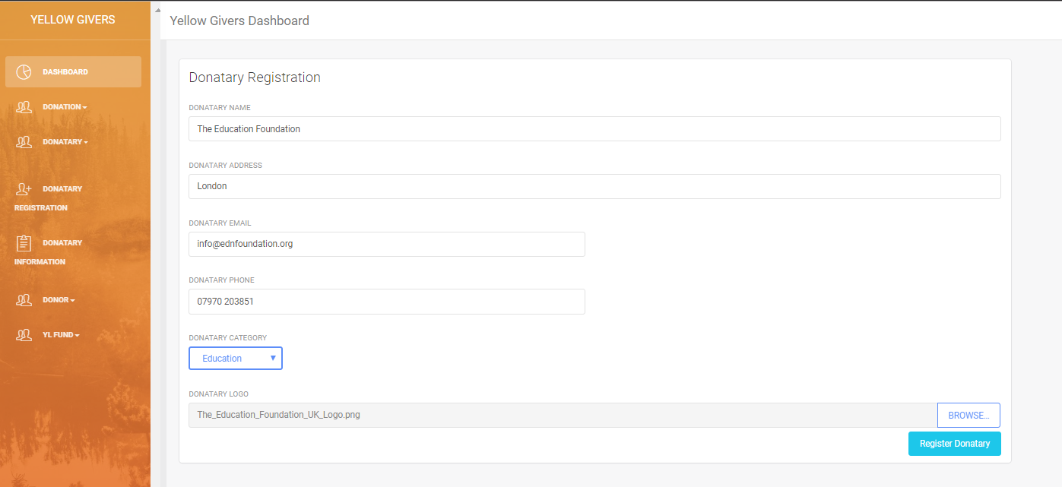

For admin to register donatary, admin require to click on donatary registration button at the left side then admin will be redirect to donatary registration page. In donatary registration page admin require to enter donatary name, donatary address, donatary email, donatary phone number, donatary category, and donation image. After all of the require information are enter then admin require to enter register donatary button.

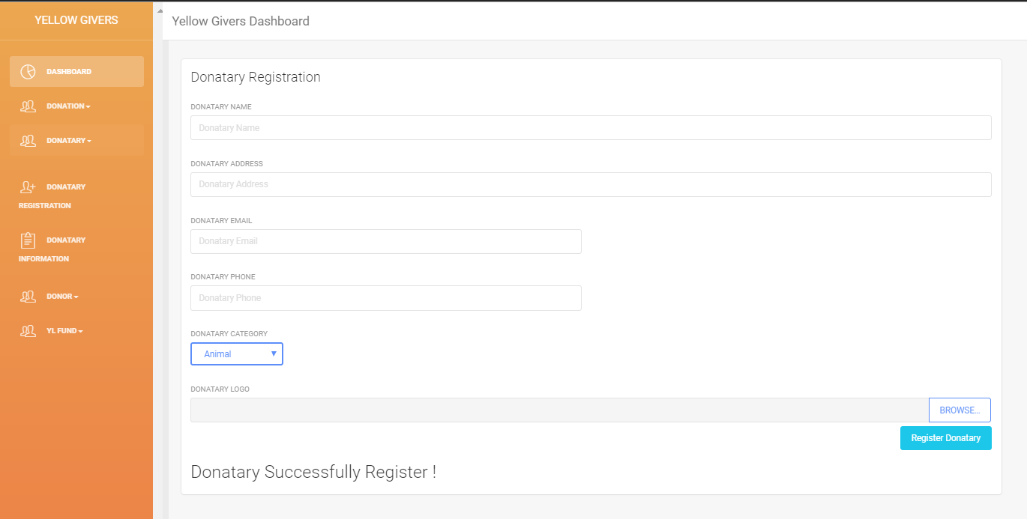

After register donatary button is click on, then the message of donatary information successfully register will appear showing that the donatary details is register into database as show in above image.

### **View Donatary**

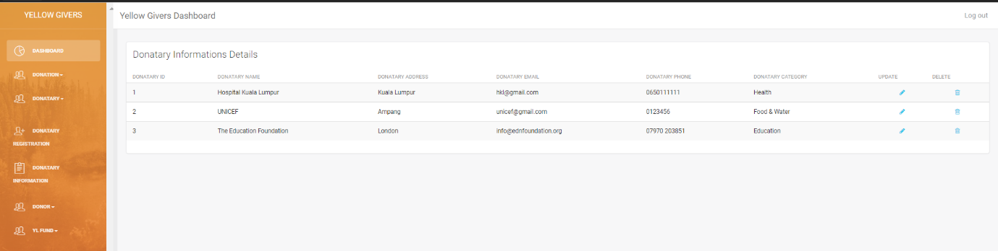

For admin to view donatary, admin require to click on donatary information button at the left side then admin will be redirect to donatary information page. In donatary information page all of the donatary information are display in this page as show in image above.

### **Update Donatary**



For admin to update donatary, admin require to click on pencil icon button at the right side then admin will be redirect to donatary update page.

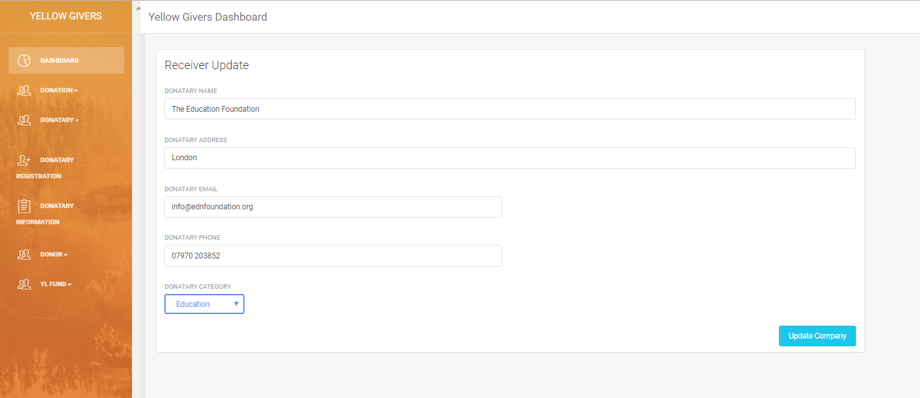

Image above is donatary update page where after admin click on pencil icon button then admin will be redirect to this page. In donatary update page admin able to update donatary name, donatary address, donatary email, donatary phone, and donatary category. After all of the required information are enter then admin require to click on update donatary button.

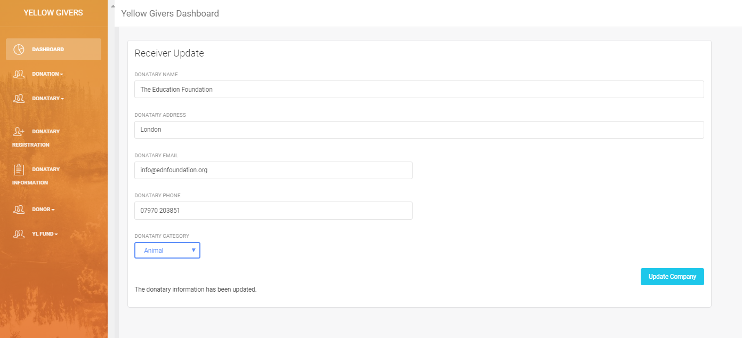

After update donatary button is click on, then the message of donatary information has been update will appear showing that the donatary details have been update into database as show in above image.

### **Delete Donatary**



For admin to delete donatary, admin require to click on trash can icon button at the right side then admin will be redirect to donatary delete page.

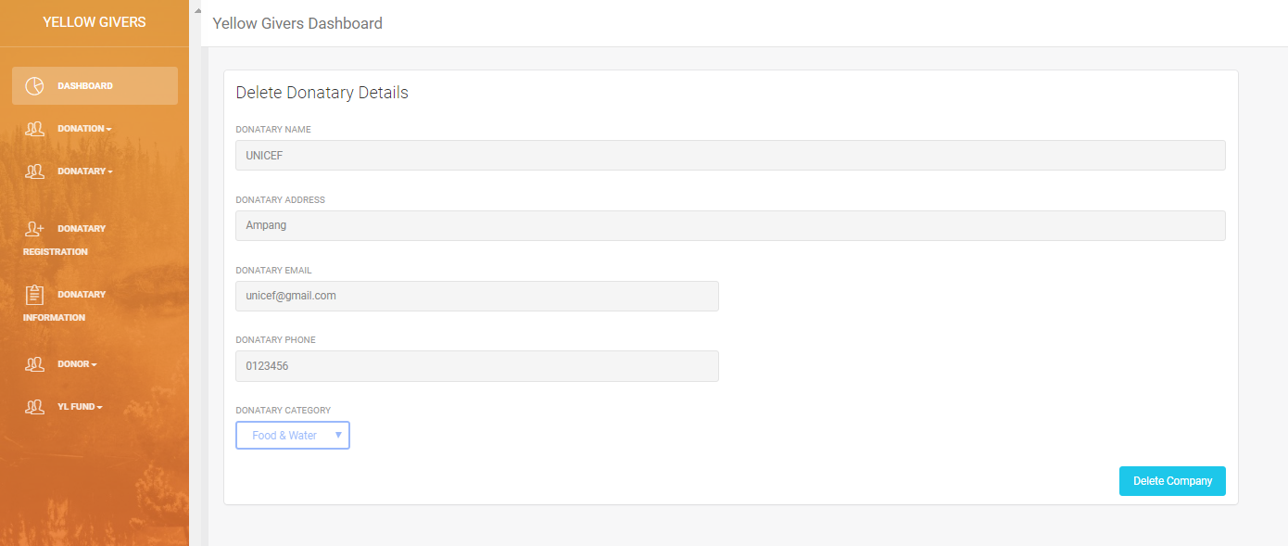

Image above is donatary delete page where after admin click on trash can icon button then admin will be redirect to this page. In donatary delete page admin can view the information of selected donatary that wish to be deleted and if admin wish to proceed the admin require to click on delete donatary button.

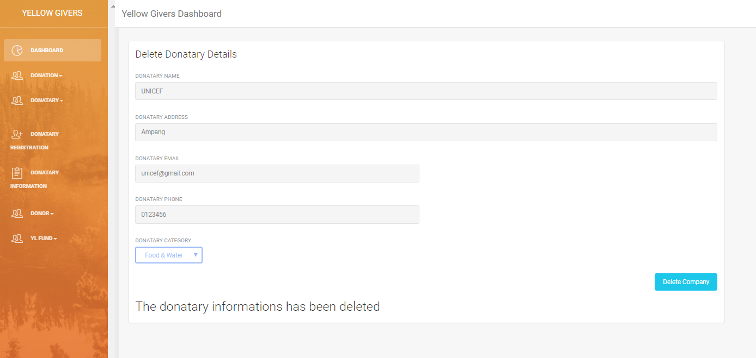

After delete donatary button is click on, then the message of donatary information has been delete will appear showing that the donatary details have been delete from database as show in above image.

### **View Donor**

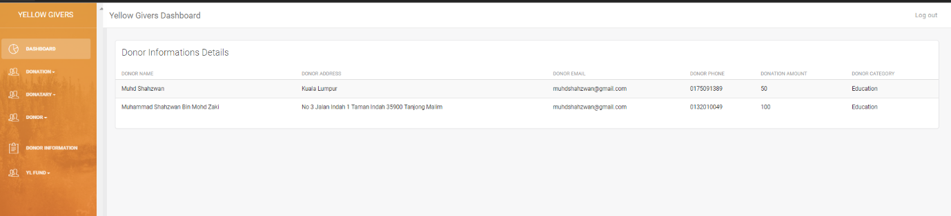

For admin to view donor, admin require to click on donor information button at the left side then admin will be redirect to donor information page. In donor information page all of the donatary information are display in this page as show in image above.

## **View Yellow Givers Fund**

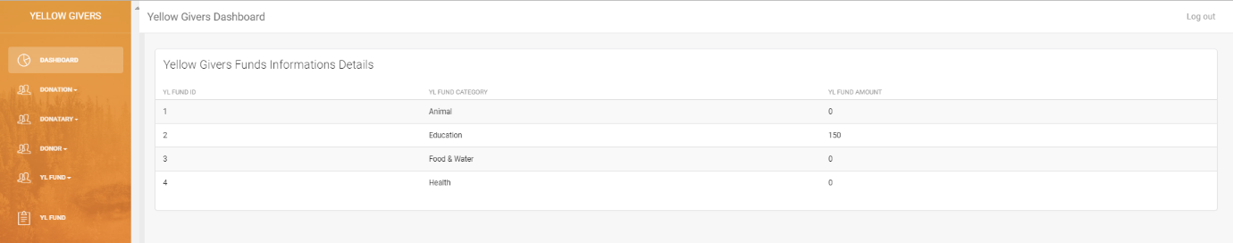

For admin to view fund, admin require to click on YL fund button at the left side then admin will be redirect to fund information page. In fund information page all of the fund information are display in this page as show in image above.

### **Notification**

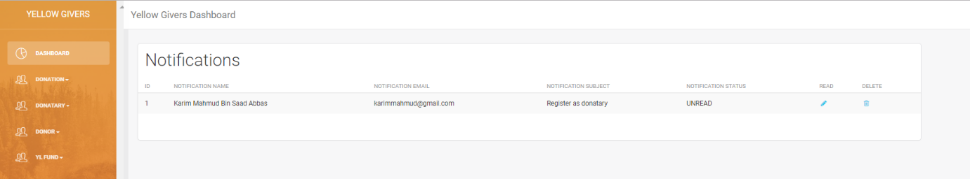

For notification it will be display at admin homepage as show as image above where admin can read or delete the notification.